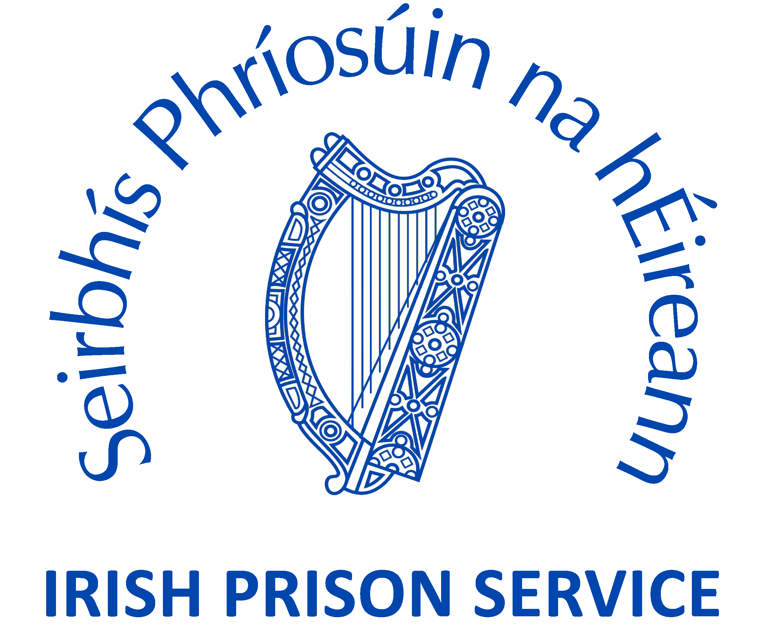

Invitation to submit Expressions of Interest
Panel of Investigators

Issued by: Irish Prison Service
Balinalee Road, Longford

February 2016
1. Background

1.1 Irish Prison Service

Political responsibility for the Prison System in Ireland is vested in the Minister for Justice and Equality. The Irish Prison Service operates as an executive agency within the Department of Justice and Equality. It is headed by a Director General supported by 4 Directors.

The Irish Prison Service deals with male offenders who are 17 years of age or over and female offenders who are 18 years of age or over.

The Irish Prison Service is administered centrally with its headquarters located at:
IDA Business Park,
Ballinalee Road,
Longford,
Co. Longford

Telephone: +353 43 33 35100
Fax: +353 43 33 35371

There are 14 institutions in the Irish Prison System consisting of eleven traditional "closed" institutions, two open centres, which operate with minimal internal and perimeter security, and one “semi-open" facility with traditional perimeter security but minimal internal security (the Training Unit).

1.2 Complaints by Prisoners

Prisoners have a number of avenues open to them if they wish to make a complaint, i.e., they can make a complaint to a member of staff, the Governor, the Prison Visiting Committee, An Garda Síochána, the Prison Chaplain, the Prison Doctor, the Minister and the Courts. Prisoners may also write to the European Commission of Human Rights and the European Committee for the Prevention of Torture and Inhuman or Degrading Treatment or Punishment (CPT). In addition, they may request to meet with officials from Irish Prison Service Headquarters to discuss any issue of concern.

1.3 Introduction of New Complaints Model

The Minister for Justice and Equality, in 2012, introduced a complaints model for the internal investigation of prisoner complaints which meets best practice and complies with Ireland’s international obligations in this regard.

The model accommodates four separate categories of complaints and three separate complaints procedures.

Category A Complaints are most serious level of complaints (assault, serious intimidation of prisoners by staff etc) and involves two elements of independent investigation/appeal – initial investigation by an external investigator on behalf of the Irish Prison Service with a right of appeal to the Inspector of Prisons (the latter is subject to the introduction of primary legislation in due course)..

Category B Complaints are mid range in terms of seriousness (discrimination, verbal abuse of prisoners by staff, inappropriate searches etc) and fall to be investigated by a Chief Officer with recourse to appeal to the prison Governor and a subsequent recourse of appeal to the Inspector of Prisons if a prisoner is unhappy with the outcome of his/her original appeal.

Category C Complaints are essentially service complaints where a prisoner is unhappy with the level of service in a particular prison (visits, phone calls, etc.) and fall to be investigated by a Prison Officer with the possibility of appeal to a Chief Officer if the prisoner is unhappy with the outcome or resolution of his/her complaint.

Category D Complaints relate to complaints against professionals such as dentists, doctors etc. Such complaints will be referred in the first instance to the prisons’ medical officer for possible resolution and, if this is not possible, to the relevant professional body responsible for regulating the professional involved.

The Inspector of Prisons has oversight of all categories of complaints.

1.4 Role of External Investigator in the investigation of Category A Complaints

The Irish Prison Service to introduced the new Category A Complaints model on 1 October, 2012.

Once the Director General (or his designate) determines that a full investigation is required, he will appoint an external investigator to carry out the substantive investigation of a complaint on behalf of the prison Governor.

The role of the investigator will be:

- to undertake the investigation of the complaint including, where necessary, meeting with complainant(s), witnesses, the subject(s) of the complaint, reviewing all relevant documentation and evidence and preparation of investigation reports; and
- to provide comprehensive file records in relation to investigations carried out.

The number of days allocated to carry out the investigation will be determined by the Irish Prison Service. The external investigation must be completed within 3 months and the Investigator’s report will be forwarded to the prison Governor and the Director General (or his designate).

The introduction of this complaints model is supported by an amendment to the Prison Rules, 2007. S.I. No.11 of 2013 Prison Rules (Amendment) 2013. Rules 57 A and 57 B.

1.5 Panel of External Investigators

The Irish Prison Service invites expressions of interest from suitably qualified candidates who wish to be considered for inclusion in a panel of investigators.

Members of the panel who satisfy the criteria outlined in these terms and conditions will be selected following assessment based on the criteria set out in Section 2.

It should be noted that it is not possible for the Irish Prison Service to guarantee any allocation of work arising from inclusion in the panel.

1.6 Qualification and Experience

At the time of the application, candidates must have:
- well developed critical thinking skills, a capacity to conduct enquiries, obtain information and to use sound judgment to reach conclusions;
- excellent analytical skills together with demonstrated experience in information collection, analysis and presentation;
- extensive evidence of planning skills to ensure delivery of results within agreed timeframes;
- excellent interpersonal skills, good levels of self confidence and a capacity for resilience in dealing with challenging situations;
- evidence of effective written communication skills; and
- evidence of proficiency with appropriate information technology databases.

Given the nature of the work, it would be desirable for applicants to have an investigative background.

1.7 Fees payable

Investigators shall be paid €150 per diem.

In addition, a maximum of €30 vouched travel expenses will be paid per day. It is in the interest of candidates to indicate which prisons or places of detention they are prepared to carry out investigations in. A full list of the prisons and places of detention within the Irish prison system and their address is attached below.

The Irish Prison Service will only be liable for the payment of an agreed number of days per investigation which will be notified to the investigator in advance of commencement of his/her investigation. The Irish Prison Service will not pay any miscellaneous costs incurred by investigators.

1.8 Taxation

It is each investigator’s responsibility to declare any payments to the Revenue Commissioners for the purposes of Income Tax. Appointed investigators may be requested to produce a Tax Clearance Certificate issued by the Revenue Commissioners. The Irish Prison Service operates the professional service withholding tax system for fees.

1.8 Scope of panel

The panel will operate for two years with an option to extend for up to an additional year.

1.9 Removal from Panel

The Irish Prison Service reserves the right to remove individual investigators for any breaches of the terms and conditions of the expression of interest. The Irish Prison Service also reserves the right to remove individual investigators where the investigator has not complied with the terms and conditions of the contractual arrangement as agreed between the investigator and the Irish Prison Service. Furthermore, the Irish Prison Service reserves the right to remove investigators from the panel should their work not be of a sufficiently high standard.

1.10 Confidentiality

Investigators will be required to sign a confidentiality agreement which will require him or her not to disclose any confidential information to any third party or otherwise use or permit any others to use same regarding cases investigated on behalf of the Irish Prison Service.

2. Selection Criteria
2.1 Closing Date for Application
Applications should be made on the attached form and should be posted to:

Ms Fiona McFaul
Operations Directorate
Irish Prison Service
Ballinalee Road
Longford

and should be received no later than 12 noon on Friday the 4th March 2016.

2.2 Initial Evaluation
Applicants will be selected for interview by a shortlisting process, the selection board will examine the information provided in your application and assess it against competencies identified for the role. It is, therefore, in your own interest to provide a detailed and accurate account of your qualifications/ experience in your application.

2.3 Selection Interview
Selection will be by competitive interview conducted by the Irish Prison Service.

It is planned to hold interviews during the week beginning 21 March 2016, with the intention that appointments will be made as soon as possible thereafter. The onus is on candidates to make themselves available for interview at short notice.

The Irish Prison Service will not be responsible for refunding any expenses incurred by applicants attending for interview.

2.4 Training
Training will be provided by the Irish Prison Service and will consist of two sessions of two days each.

It is intended to hold the first two day session early April in the Irish Prison Service College in Portlaoise. This session will include an introduction to the Irish Prison Service, the New Complaints Model and Ireland’s Human Rights obligations to prisoners.

The second session will focus on investigation training and will be held soon thereafter.

SERIOUS COMPLAINTS INVESTIGATOR
APPLICATION FORM
APPLICANTS MUST SIGN THIS FORM. APPLICATIONS MUST BE MADE USING THIS FORM
CV’S ARE NOT ACCEPTABLE.
Please use BLOCK CAPITALS
PERSONAL DETAILS:
SURNAME: | FIRST NAME: |  | TITLE: (Mr, Mrs, Ms, Other (specify)
ADDRESS:
(for correspondence)

Name of firm:
(if appropriate)

DAYTIME PHONE No.: | MOBILE No.: | E-MAIL:
VAT Number:
(If applicable)
Withholding Tax Number:
(If applicable)
Bank account for payment: | Bank Name  Bank Address  A/c Number:……………………  Bank sort code:……………….  A/c name: ………………………….
Tax Clearance Certificate enclosed  (If applicable) | YES:  NO: 
Personal Public Service (PPS) Number

CAREER DETAILS:
DATES FROM – TO:
Employer’s Name  and Address: |  | Position Held:
Details of Responsibilities

DATES FROM – TO:
Employer’s Name  and Address: |  | Position Held:
Details of Responsibilities

DATES FROM – TO:
Employer’s Name  and Address: |  | Position Held:
Details of Responsibilities

DATES FROM – TO:
Employer’s Name  and Address: |  | Position Held:
Details of Responsibilities

RELEVANT PROFESSIONAL QUALIFICATIONS
Qualification | Awarding Institution | Date Awarded

MEMBERSHIP OF PROFESSIONAL BODIES
Official Name of Body | Grade of Membership | Dates of Membership

I wish to be assigned cases from the following prison(s) and place(s) of detention – (please tick)

Mountjoy Prison | Committal prison for adult male prisoners, at North Circular Road, Dublin 7.
Dóchas Centre | Committal prison for female prisoners aged 18 years and over at North Circular Road, Dublin 7
St. Patrick’s Institution | An institution for male juveniles aged 17 who are on remand, at North Circular Road, Dublin 7.
The Training Unit | A semi-open place of detention for male prisoners aged 18 years and over, at Glengarriff Parade, Dublin 7, for industrial training.
Arbour Hill Prison | Prison for adult male prisoners, at Arbour Hill, Dublin 7.
Wheatfield Place of Detention | Place of detention for adult males and for sentenced 17 year old juveniles. at Cloverhill Road, Clondalkin, Dublin 22.
Cloverhill Prison | Committal prison for remand adult male prisoners, at Cloverhill Road, Clondalkin, Dublin 22
Loughan House | An open centre for the detention of male prisoners aged 18 years and over, at Blacklion, Co. Cavan
Castlerea Prison | Committal prison for adult male prisoners, at Harristown, Castlerea, Co. Roscommon.
Shelton Abbey | An open centre for male prisoners aged 19 years and over, at Arklow, Co. Wicklow
Limerick Prison | Committal prison for adult male and female prisoners, at Mulgrave Street, Limerick.
Cork Prison | Committal prison for adult male prisoners, at Rathmore Road, Cork.
Portlaoise Prison | Prison for adult male prisoners, including the detention of high security prisoners, at Dublin Road, Portlaoise, Co. Laois
Midlands Prison | Prison for adult male prisoners, at Dublin Road, Portlaoise, Co. Laois.

OTHER INFORMATION

Please provide here any other information which you would consider relevant to your application.

REFEREES

Please provide details of 2 referees to whom you are well known in a professional capacity (if you are in existing employment, one of the referees should be an existing employer).

Name:  Occupation/Designation:  Address:  E-Mail:  Phone No: | Name:  Occupation/Designation:  Address:  E-Mail:  Phone No:

DECLARATION

I hereby confirm that all the above details are correct and accurate.

I further confirm that:

  - I am not currently and have never been the subject of any disciplinary proceedings relating to my professional conduct before any committee, tribunal, court or other similar body, other than proceedings in which the complaint has been found to be unwarranted.

  - I am willing to serve as an investigator in accordance with the terms and conditions outlined in the above document.

  - I will notify the Irish Prison Service of any potential conflict of interest that I may have in the investigation of any complaint.

  - I will undertake not to disclose any information obtained during the course of an investigation to any third party.

Name: _____________________________________

Date: _______/_______/________

